Policies_Verifying Agency Billed Policy_Instance43_29-May-2018_03-25-47_AM_SingleSignOn.png

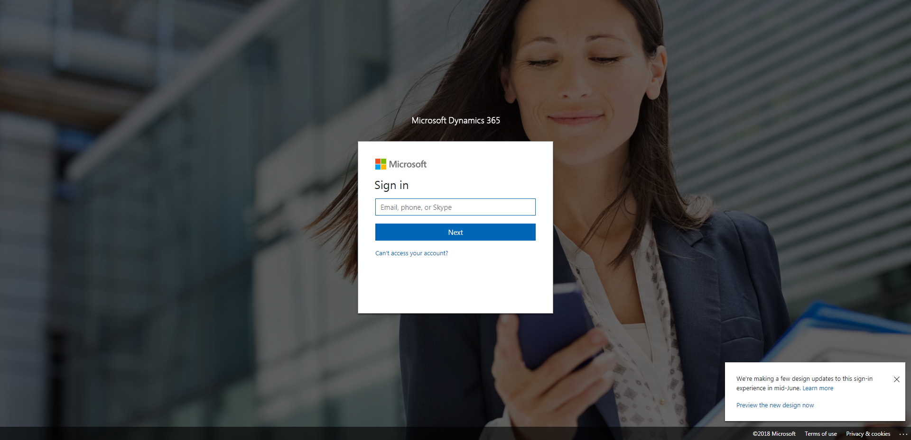

Policies_Verifying Agency Billed Policy_Instance43_29-May-2018_03-25-49_AM_ValidationofAgencyBilledPolicy.png

